Medication: Click here to enter text.

What do I do when I get the medication from HomeMed?
- Always check the prescription and label for final instructions.
  - check your name
  - medication name and dose
  - how frequently the medication should be given
- If the information does not match, contact HomeMed immediately
at 800-862-2731.
- Check the syringes for expired dates, color changes, leaks and floating materials. If these occur, set aside and use another. Notify HomeMed.
- Check that the outer red sleeve of the tamper-evident cap is attached securely. If not, do not use the syringe and notify HomeMed.
- Check medication labels for storage instructions.
- If your medication needs to be refrigerated, bring to room temperature by removing dose several hours before giving it.

What do I need to do to prevent infection?
- Work at a comfortable pace. The risk of contamination increases if you rush.
- Always wash your hands for 15 seconds with soap or an instant hand sanitizer before any procedure. Do not touch anything dirty, such as your clothes, glasses or skin after washing your hands. If you do, rewash them.
- If you wish to use an instant hand sanitizer, use one that contains ethanol in concentrations between 60-90%. Do not use an instant hand sanitizer if your hands are visibly soiled or you have a C. difficile infection.

What supplies do I need?
One (1) Prefilled medication syringe
One (1) Prefilled heparin flush syringe (remove from package)
Two (2) Prefilled saline flush syringes (remove from package)
One (1) Alcohol cap
Four (4) Alcohol pads
Household disinfectant or alcohol
Soap
Paper towel

How do I prepare for the procedure?
- Place a trash can next to your work area.
- Clean your work surface or laminate mat with household disinfectant. Let the area air dry.
- Wash your hands as follows:
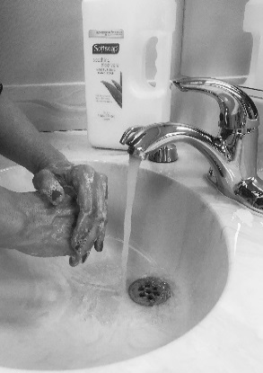
  - Wet your hands and wrists under running water.
  - Scrub vigorously with soap for 15 seconds.
  - Work lather between fingers, under nails, over the palms and back of hands.
  - Rinse hands well by keeping your hands up with fingers pointing up towards the ceiling so that the dirty water runs toward your elbows.
  - Dry your hands with a clean paper towel from tips of fingers down.
  - Turn off the faucet with the paper towel.
- Gather your supplies and place onto your work area.
- Wash your hands again.

How do I give the medication?
- Check your catheter cap to make sure it is on securely (always hold your catheter cap while connecting/disconnecting to prevent accidental removal).
- Unclamp your catheter and remove the green alcohol cap.
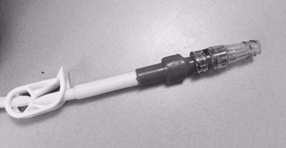
- Vigorously scrub the end of the cap on your catheter with an alcohol pad for fifteen seconds.
Valved
IV catheter cap
- Hold the prefilled saline syringe upright.

- Do not remove the cap. Press forward on the plunger to break the seal. Do not pull back on the plunger.
- Gently tap the sides of the syringe so the bubbles rise to the top. Remove the cap and push the plunger to remove all the air.
- Push and twist the saline syringe into your catheter cap to the right until secure.
- Inject the saline solution. Remove and discard syringe in your trash.
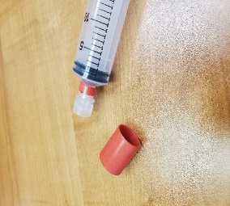
- Vigorously scrub the end of the cap on your catheter with an alcohol pad for fifteen seconds.
Remaining Cap
- Remove the outer red sleeve from your medication syringe and discard.
- Unscrew the remaining clear cap and discard.
- Push and twist the medication syringe into your catheter cap to the right until secure.
Outer Sleeve
- Push on the medication syringe plunger and give prescribed dose over the number of minutes indicated on the prescription label.
- After you inject all your medication, remove the syringe and discard in your trash.

- Repeat steps 3-8 to flush your catheter cap with saline then heparin. Do leave a small amount of heparin in the syringe, and clamp your catheter before removing the syringe. Place a new alcohol cap onto the end of your IV catheter cap.

How can I remember the steps?
Follow S-A-S-H when you give the medication:
S - saline flush
A - administer medication
S - saline flush
H - heparin flush

What if I still have questions?
- For on-line video and resources, please visit: https://homecare.med.umich.edu/HomeMed/Patient-Resources
- Call HomeMed. Our 24-hour number is 800-862-2731.
- Please identify yourself to the hospital operator as a HomeMed patient.

In summary: These are the steps to follow when you give your medication IV push:
- Wash your hands
- Flush your IV catheter with saline
- Push medication dose over the number of minutes indicated on the prescription label.
- Flush your IV catheter with saline
- Flush your IV catheter with heparin
- Place a new alcohol cap on the end of your IV catheter

Disclaimer: This document contains information and/or instructional materials developed by Michigan Medicine for the typical patient with your condition. It may include links to online content that was not created by Michigan Medicine and for which Michigan Medicine does not assume responsibility. It does not replace medical advice from your health care provider because your experience may differ from that of the typical patient. Talk to your health care provider if you have any questions about this document, your condition or your treatment plan.

Patient Education by Michigan Medicine is licensed under a Creative Commons Attribution-NonCommercial-ShareAlike 4.0 International Public License. Last Revised 11/2024.

