Using a Kangaroo™ Joey Feeding Pump

HomeMed



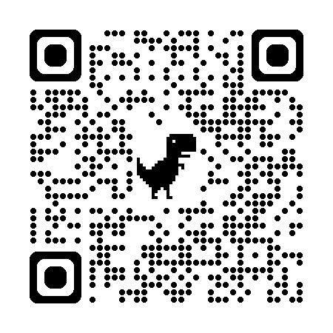
Table of Contents:
Key Points……...........................................................................3
How do I use a Kangaroo™ Joey feeding pump?……...5-9
How long can the formula hang in the bag?...................10
Battery information…...........................................................11
How do I attach the pole clamp?……................................12
How do I clean the pump?….…..........................................12
Pump safety…….....................................................................13
Troubleshooting the Kangaroo™ Joey Pump….........14-17
What do I do if the pump won’t work or if the power goes out?……...........................................................................18
How do I use the syringe feeding method?…................19
How do I use gravity feeding method?……..............20-21
To view the Joey pump training video, please visit the following web link or scan the QR code below. https://homecare.med.umich.edu/HomeMed/Patient-Resources/Joey-Pump

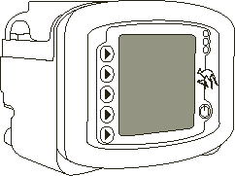
Key points to remember when using a Kangaroo™ Joey feeding pump:
- Wash your hands with antibacterial soap before using your feeding tube and supplies.

- If you have more than one catheter (example: feeding tube and IV), always make sure you are putting the formula into the feeding tube and not into the IV (intravenous) line.

- Use a new Kangaroo™ Joey feeding bag each day unless told to do something differently. You may save your last feeding bag and reuse it for several days if you have not received your delivery yet. Please contact HomeMed 3-4 days in advance if you think you are going to run out of feeding bags.

- If the pump will not work or if the power goes out, refer to page 18 for instructions.

- Keep supplies and formula in a dry, clean area.

- Do not use supplies if: the seal is broken, the package is torn, or the inside or outside of the package is wet.

- Check your formula for expiration dates. Do not use formula if the expiration date has passed. See page 10 for instructions on how much formula you can add to the bag each feeding.

- Keep your pump plugged into the wall as much as possible.

- Never mix medications in with the formula unless the doctor has told you to. Medicine should be given separately with a syringe through the tube.
- Always shut off the pump before taking the tubing out. Taking the tubing out while the pump is on (or holding) may cause errors.

- Clean your pump weekly to keep the pump working correctly (see page 12).

How do I use a Kangaroo™ Joey feeding pump?
To choose the functions on the pump, push the button next to the words.

Step 1: Prepare the feeding set
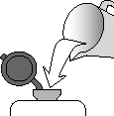
- Place your feeding set on a clean surface.
- Pull open the plastic cap of the feeding set and pour the formula into the bag. Close the cap by pushing down on the top and fastening the tab. Ask your nutritionist how much formula to add to the feeding bag at a time. Formula can spoil if it hangs in the bag too long.
Note: If you blenderize your formula, let the mixture stand for 10-15 minutes before adding to the feeding bag. This will decrease the chance of an alarm due to air in the tubing.
- Hang the bag on the IV pole so the bottom of the bag is just above the pump. It is important that you do not hang the bag more than a couple inches above the pump lid.
- Remove the plastic protector from the end of the feeding set.

Step 2: Turn on the pump
- Press the power button . The pump will beep and show 2 kangaroos jumping across the screen.
- The pump will display “prior settings” at the top of the screen.
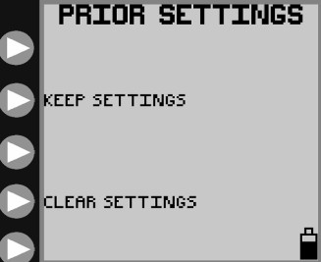
- If this if your first time using the pump choose “clear settings”. If you have already programmed your pump before this, choose “keep settings”.
- The screen will now display “load a set”. A “set” is another name for feeding bag.

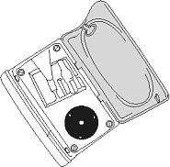
Step 3: Attach the feeding bag to the pump
- With the pump screen facing you, lift up on the blue lid to open the top of the pump.

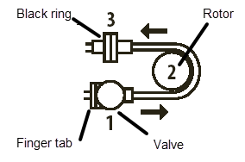
- To load the tubing into the pump, grasp the finger tab on the light purple valve and slide the valve into the front channel of the pump. Make sure to push the valve all the way into the channel. Wrap the tubing around the rotor (black wheel) and pull gently until you can slide the black ring into the back channel (do not over-stretch the tubing).
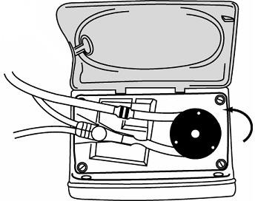

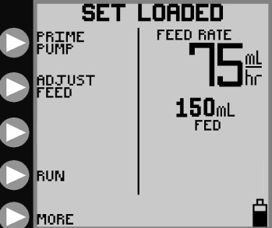
- Close the blue lid.
- The pump will now display “set loaded” on the screen.

Note: If you have loaded the pump correctly and it continues to show “load a set”, you may have a defective bag. Refer to page 17 for “loading a set”.

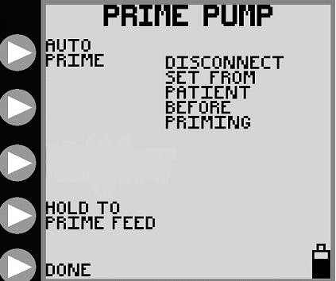
Step 4: Prime the tubing
The feeding set must be primed with formula before
connecting it to your feeding tube. Priming means running the formula through the feeding set to get rid of air.
- Choose “prime pump”.
- Choose “auto prime” and the pump will fill the tubing with formula.
- If the formula does not reach all the way to the end of the tubing, you may press and hold “hold to prime feed” until the formula reaches the end.
- Choose “done”.

Step 5: Program the pump for the first time

If you have already programmed your pump before this use, check to make sure the feed rate is the correct rate for the feeding. If it is correct, you may skip this step.
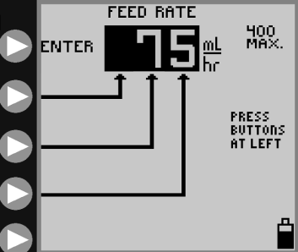
- Choose “adjust feed”.
- Press the buttons to increase each number separately. As you push each number, it will increase from 0 to 9 and then start back at 0.
- Choose “enter” when you have the correct rate entered.

Step 6: Run the pump
- Connect the purple tip of the feeding set to the patient’s feeding tube.
- Choose “run” and the pump will begin infusing your formula. The pump will now show “running” at the top of the screen. A picture of a drop will start moving down the screen. This shows that the pump is running.
- If you need to pause or stop the feeding at any time, you may choose “hold”. Choose “run” when you are ready to re-start the feeding. The pump can be on “hold” for 10 minutes before it alarms.
- When the feeding is done, press and hold the power button (which looks like this: ) until the pump shuts off. Throw the bag out if it has been used for 24 hours unless told to do something differently. If you are going to restart your feeding right away with the same bag, leave the tubing in the pump to rinse it out. See Step 7 “Rinsing the feeding bag”.

Step 7: Rinse the feeding bag
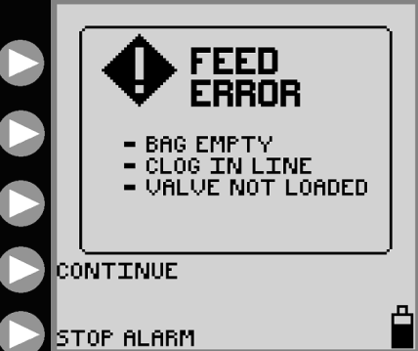
The feeding bag should be rinsed out with water before you add more formula or if you are going to save the bag to use later. The same feeding bag should be used for 24 hours unless you are told to do something differently. Note: The tubing should be left in the pump for rinsing between feedings. If you need to take out the tubing from the pump, always turn the pump off first. If the tubing is removed from the pump while the pump is on or in the “holding” mode, it will cause the pump to error.

Follow these instructions to rinse the feeding bag:
- When the bag is empty, the pump will show the message “feed error”. Push the “continue” button and then the “hold” button.

- Take the purple end of the feeding bag from your feeding tube.

- Pour about 1 cup of warm water (no soap) into the feeding bag, close the top and shake the bag. Dump the water into the sink and repeat 2-3 times or until the bag is clear.

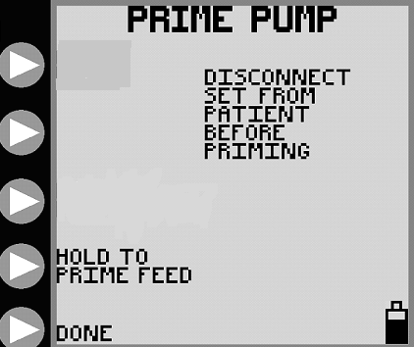
- To rinse the tubing portion of the bag, add another small amount of warm water to the bag.

- Press “adjust settings” then “prime pump”.

- Hold the purple end of the tubing over a sink or cup and “prime” all the water through the tubing to rinse. You will be using the “hold to prime feed” button.

- To continue feeding start at Step 1. If you are not going to restart the feeding right away, the feeding set can hang on the IV pole until the next feeding scheduled.

How long can the formula hang in the feeding bag?
- Formula may spoil if it is left at room temperature for too long after being opened.
- Different types of formula have different hang times.
- Only add enough formula to the feeding bag so that it does not hang longer than recommended (see below).

Type of formula | Maximum Hang Time
Ready-to-feed liquid formula in a can | 8 hours
Ready-to-feed liquid formula in a can + added water, oils, protein, carbohydrate, or electrolytes | 4 hours
Powder or liquid concentrate formula + added water | 4 hours
Breastmilk | 4 hours (less is better)
Breastmilk plus calorie booster | 2 hours

To find out how much formula you can add to your bag each time you refill, use this simple calculation:
Pump rate x maximum hang time = how much formula you add to the bag
 | Example: | Your formula:
Pump rate: | 40 mL/hr
Maximum hang time: | 4 hours: (powdered formula and water)
Total: | 160 mL of formula to bag

Always rinse out the feeding bag and tubing with water before adding more formula.
Battery Information
- Keep the pump plugged into a wall outlet whenever possible to keep the battery fully charged. The pump will charge whether it is turned off or running.
- When using the power cord, make sure the cord adaptor is pushed all the way into the back of the pump for proper charging.
- The battery will last for about 18 hours if fully charged. It takes about 8 hours to re-charge.
- The pump shows a battery icon in the lower right corner of the screen to show how much battery life is left. A totally black battery icon means that the battery is fully charged.
- The pump will display “battery low” when there is about 15 minutes of battery life left. You may continue to run the pump if you plug the power cord into an outlet.
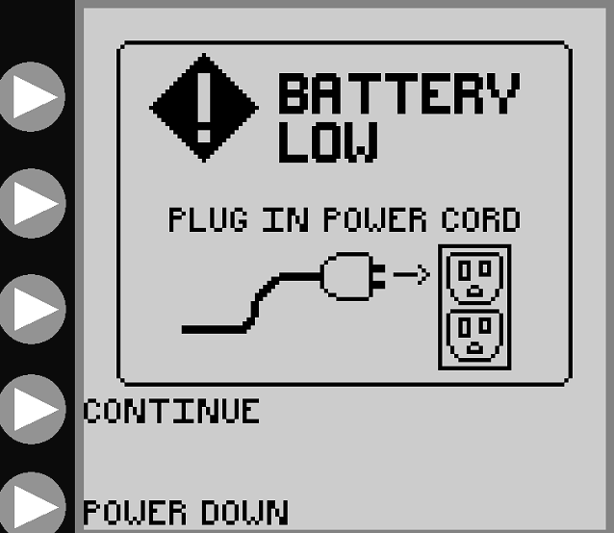

How do I attach the pole clamp?
- Slide the clamp on the silver mounting stud on the back of the pump.
- Turn the lever to tighten.
- The power cord can be wrapped around the pole clamp if it is too long. This will help make sure the power cord does not accidentally get pulled from the back of the pump.
- The pump clamp can be changed so that the pump sits in front of the pole instead of off to the side. Take the pump off the pole clamp. Use a coin or a large screwdriver to loosen the silver bolt. Turn the silver portion around and re-tighten the bolt.
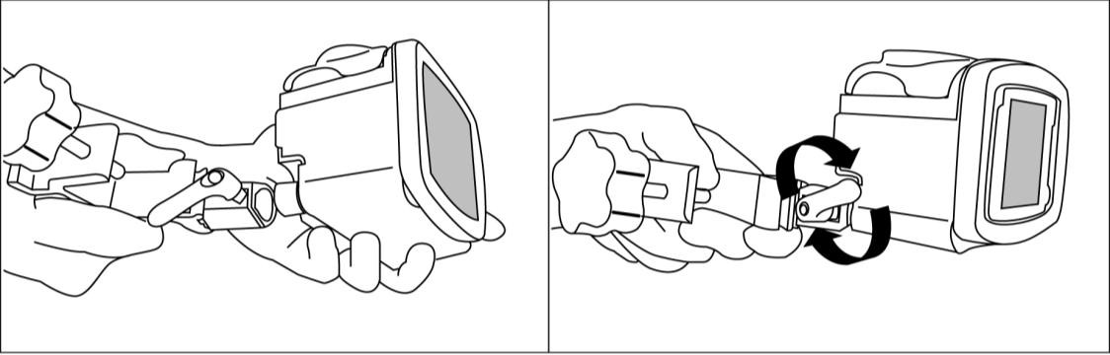

How do I clean the pump?
- Do not put the pump or power cord in water or other cleaning solutions.
- Take out the power cord before cleaning the pump.
- Clean the pump using a mild soap and a damp cloth or sponge.
- You can use a very diluted bleach solution (1 part bleach to 10 parts water) or alcohol on a cotton swab for hard to reach areas. This should not be done all the time as doing it too often may damage the pump.
- Do not use other cleaning solutions on the pump.

Pump safety
- Do not drop or hit the pump. If the pump is dropped, always check the pump to be sure it is still working correctly.
- Other electronics in the home may affect the operation of the feeding pump. However, the Joey will not be affected by most sources. Possible sources of interference include: cell phones, cordless telephones, microwave ovens, security systems etc.

Travel
- If you plan to travel for a long period of time, please make sure you are prepared in advance with enough supplies to take with you.
- If you use a pump to give your feedings and you are traveling out of state, we will be able to provide you with a back-up pump to take with you.
- If you will be taking your feeding pump on an airplane, please call HomeMed for further instructions.

Troubleshooting the Kangaroo™ Joey pump
The Joey pump will sound an alarm and show a message on the screen if there is a problem during use. Refer to the following pages to resolve errors or alarms.
Please call HomeMed if you need help at (800) 862-2731.

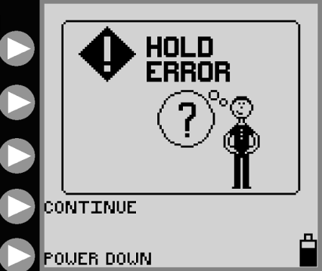
Hold error:
The pump has been on hold for 10 minutes and is waiting for the next step. Press “continue” to return to the previous screen or “power down” to shut off the pump. If this does not fix the problem, press the power button to turn the pump off and then turn the pump back on.

Rotor error:
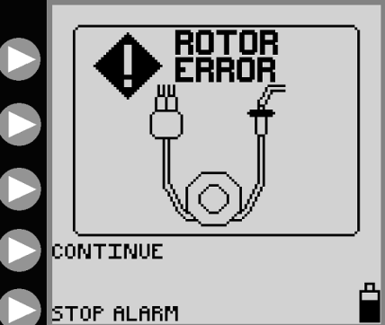
There is a problem with the rotor (black wheel) and is usually related to the tubing being placed incorrectly. Remove tubing from the pump and inspect the tubing for damage. If no damage, reload the tubing and press “continue”. If this does not fix the problem, press the power button to turn the pump off and then back on.

Feed error:
The feeding bag may be empty and need to be refilled. Refer to Step 7 on page 8 and press “continue” to resume feeding. There may be a clog or kink in the tubing between the bag and the pump. Clear the kink and press “continue”. If this does not fix the problem, press the power button to turn off the pump and then back on. You may need to try a new feeding bag.

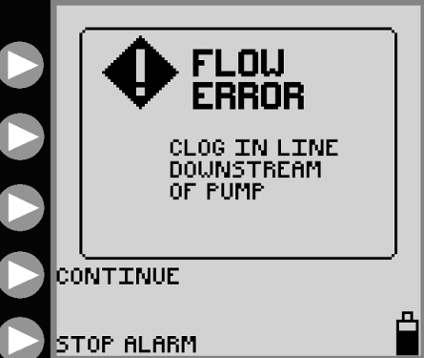
Flow error:
There may be a kink in the tubing between the pump and the feeding tube. Clear the kink and press “continue”. If this does not fix the problem, the channel which holds the tubing in the pump may be dirty. Refer to page 12 for “Cleaning the Pump”. If this does not fix the problem, press the power button to turn off the pump and then back on. You may need to try a new feeding bag.

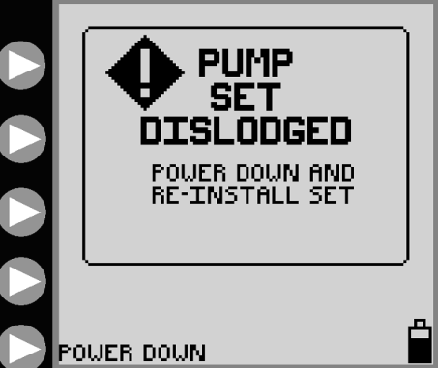
Pump set dislodged:
The tubing may not be loaded correctly into the pump. Remove the tubing and re-load. If this does not fix the problem, press the power button to turn off the pump and then back on. You may need to try a new feeding bag.

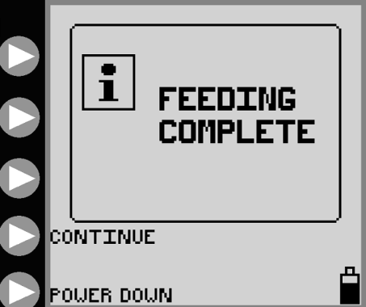
Feeding complete:
The feeding is done. Refer to number 7 on page 9 to continue feeding. Press “power down” to shut off the pump.

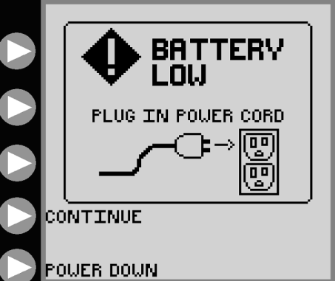
Battery low:
There are only 15 minutes of battery life left. Plug the power cord into an outlet and press “continue”. If the power cord is already plugged into an outlet, check to make sure the cord adaptor is pushed all the way into the back of the pump. Check to make sure your outlet is working by plugging in another electrical device.

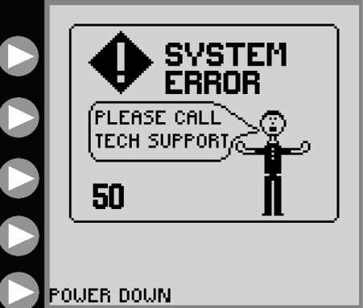

System error:
The pump has a malfunction and must be turned off. Press “power down” and try to turn the pump back on. If this does not fix the problem, call HomeMed for assistance. You may need a new pump.

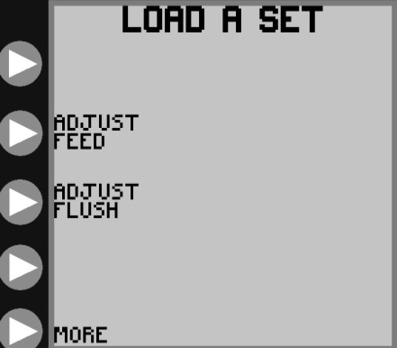
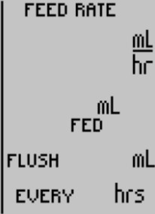
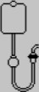


Load a set:
This is not actually an error screen but you may experience a problem where the pump does not know that a feeding bag is loaded. Make sure you have loaded the tubing correctly and that the valve is pushed all the way into its slot. If the pump still does not show “set loaded” then you have a defective feeding bag. Try using a different bag and call HomeMed during regular business hours to replace the defective feeding bag.

What do I do if the pump will not work or if the power goes out?

Use one of the non-electric feeding methods:
- Feed with a syringe (page 19).
- Feed with a gravity bag using hourly rate calculations (page 20-21).

Note: Children with tubes placed in the duodenum or jejunum will not be given a gravity bag for feedings. Please refer to syringe feeding instructions for a way to give feedings.

How do I use the syringe feeding method?
- Wash your hands with an antibacterial soap and water.

- Flush feeding tube with water before the feeding.

- Prepare your formula as instructed by your HomeMed clinician.
  - Using a syringe, pull up ¼ or 0.25 of the hourly rate of formula.
  - Slowly push the formula into the feeding tube.
  - Repeat the process every 15 minutes.

To find out how much formula to pull into the syringe, use this calculation:

Example:
40 mL (hourly rate) x 0.25 (or ¼) = 10 mL. You will give 10 mL of formula every 15 minutes.

- Flush the feeding tube with water after the formula has been given.

- If the volume is well tolerated, try giving half the volume of formula every 30 minutes.

If formula is usually given at night, the syringe feedings can be given during the following day.

How do I use gravity bag?

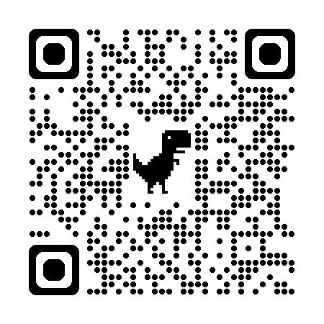
The Kangaroo™ Joey feeding bag will not run by gravity. Please use the gravity feeding bag that was sent in your first delivery. To use your gravity bag, follow the instructions below or scan the QR code to watch a gravity feeding training video.

(Children with feeding tubes placed in the duodenum or jejunum should refer to syringe feeding instructions on page 19.)

Get the following supplies:
  - Gravity tube feeding bag
  - Formula
  - A cup of warm water
  - Syringe for flushing

Setting up:
- Wash your hands with antibacterial soap and water.
- Flush your feeding tube with the recommended amount of water.
- Prepare your formula as instructed by the dietitian or HomeMed clinician.
- Be sure the roller clamp on the gravity feeding bag is closed (roll the wheel all the way down).
- Pour 1-2 cans of formula into the feeding bag.
Hang the feeding bag on the IV pole. If you do not have an IV pole, use a hook or nail in the wall to keep the feeding bag secure. The gravity bag must be above the level of the chest and stomach to work.
- To prime the tubing, squeeze and release the drip chamber until the formula fills to the line etched in the chamber. Open the roller clamp to allow the formula to flow to the end of the tubing. Close the clamp.
- Insert the end of the feeding bag into your feeding tube, unroll the roller clamp and allow formula to flow until the feeding bag is empty (refer to the chart below for rate calculations).
- Flush your feeding tube with the recommended amount of water.

Example of gravity bag feeding with hourly rate calculations
You can control how fast the formula is given by gravity by adjusting the roller clamp. Watch the drip chamber and time the drips according to the calculations below.

If pump rate is: | Drop rate should be:
60 mL per hour | 4 drops every 15 seconds
80 mL per hour | 5 drops every 15 seconds
100 mL per hour | 6 drops every 15 seconds
120 mL per hour | 7 drops every 15 seconds
140 mL per hour | 8 drops every 15 seconds

Disclaimer: This document contains information and/or instructional materials developed by the Michigan Medicine for the typical patient with your condition. It may include links to online content that was not created by Michigan Medicine and for which Michigan Medicine does not assume responsibility. It does not replace medical advice from your health care provider because your experience may differ from that of the typical patient. Talk to your health care provider if you have any questions about this document, your condition or your treatment plan.

Reviewers: HomeMed Patient Education Committee
Last Revised 05/2020

Patient Education by Michigan Medicine is licensed under a Creative Commons Attribution-NonCommercial-ShareAlike 4.0 International Public License.

