Medication: Click here to enter text.

What do I do when I get the medication from HomeMed?
- Always check the prescription and label for final instructions.
  - check your name
  - medication name and dose
  - how frequently the medication should be given
- If the information does not match, contact HomeMed immediately
at 800-862-2731.
- Check the bags and syringes for expired dates, color changes, leaks and floating materials. If these occur, set aside and use another. Notify HomeMed.
- Check medication labels for storage instructions.
- If your medication needs to be refrigerated, bring to room temperature by removing dose several hours before giving it.

What do I need to do to prevent infection?
- Work at a comfortable pace. The risk of contamination increases if you rush.
- Always wash your hands for 15 seconds with soap or an instant hand sanitizer before any procedure. Do not touch anything dirty, such as your clothes, glasses or skin after washing your hands. If you do, rewash them.
- If you wish to use an instant hand sanitizer, use one that contains ethanol in concentrations between 60-90%. Do not use an instant hand sanitizer if your hands are visibly soiled or you have a C. difficile infection.

What supplies do I need?
One (1) IV medication bag
One (1) Gravity IV tubing
One (1) Flow controller extension set
One (1) Luer lock cap (white cap to keep IV tubing sterile after use)
One (1) Prefilled heparin flush syringe (remove from package)
Two (2) Prefilled saline flush syringes (remove from package)
Four (4) Alcohol pads
One (1) Alcohol cap
Household disinfectant or alcohol
Soap
Paper towel

How do I prepare for the procedure?
- Place a trash can next to your work area.
- Clean your work surface or laminate mat with household disinfectant. Let the area air dry.
- Wash your hands as follows:
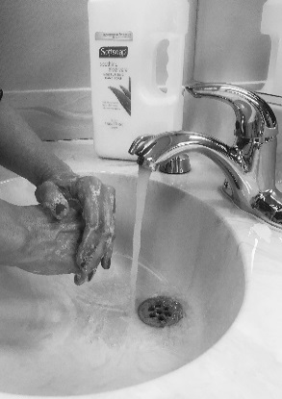
  - Wet your hands and wrists under running water.
  - Scrub vigorously with soap for 15 seconds.
  - Work lather between fingers, under nails, over the palms and back of hands.
  - Rinse hands well by keeping your hands up with fingers pointing up towards the ceiling so that the dirty water runs toward your elbows.
  - Dry your hands with a clean paper towel from tips of fingers down.
  - Turn off the faucet with the paper towel.
- Gather your supplies and place onto your work area.
- Wash your hands again.

How do I prepare the tubing?
IV tubing spike
- Attach the gravity IV tubing to the flow controller extension set.  - remove the cap from the end of the gravity IV tubing  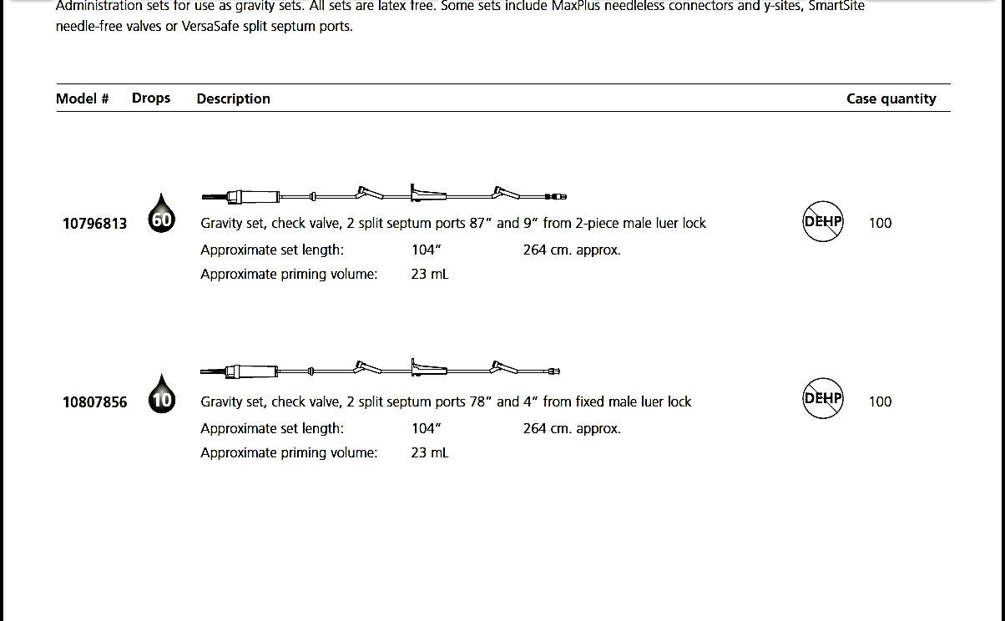  - remove the cap on the shorter end of the flow controller tubing and attach it to the gravity IV set by twisting at the luer lock connection  - Turn flow controller to “off” position.  - Remove the tab from the IV bag.  - Remove the spike cover from the IV tubing. Do not touch the spike.  Connect this end to flow controller  - Hold the port of the IV bag straight and insert the spike by pushing and twisting at the same time.  - Hang the IV bag with the attached tubing on the IV pole.  - Squeeze and release the drip chamber on the IV tubing until it is half full of fluid.  - Turn the flow controller to “open” to fill the IV tubing with fluid.  - When the fluid is at the end of the IV tubing, turn the flow controller to “off”.  - Hang the IV tubing over the IV pole. Do not let the tubing fall on the floor.  - Place the expiration label on the IV tubing to remind you to change it in 72 hours (3 days). | Roller clamp  Drip chamber  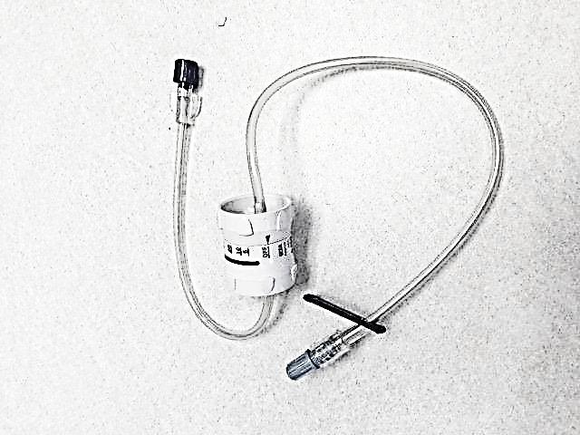  Connect this end of the flow controller to your IV catheter cap  ©CareFusion Corporation

How do I give the medication?
- Check your catheter cap to make sure it is on securely (always hold your catheter cap while connecting/disconnecting to prevent accidental removal).
- Unclamp your catheter and remove the green alcohol cap.
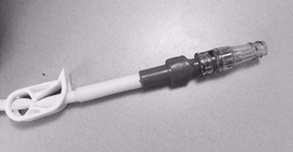
- Vigorously scrub the end of the cap on your catheter with an alcohol pad for fifteen seconds.
Valved
IV catheter cap
- Hold the prefilled saline syringe upright.

- Do not remove the cap. Press forward on the plunger to break the seal. Do not pull back on the plunger.
- Gently tap the sides of the syringe so the bubbles rise to the top. Remove the cap and push the plunger to remove all the air.
- Push and twist the saline syringe into your catheter cap to the right until secure.
- Inject the saline solution. Remove and discard syringe in your trash.
- Vigorously scrub the end of the cap on your catheter with an alcohol pad for fifteen seconds.
- Remove and discard the protective cap from the flow controller extension set.
- Push and twist the luer lock into your catheter cap to the right until secure.
- Turn the flow controller to the rate noted on the bag label in order to infuse over the correct amount of time.

How do I stop the medication?
- When the infusion is done, turn the flow controller to “off”.
- Wash your hands.
- If the tubing has been used less than three days, disconnect the IV tubing from the cap on your catheter and place a new white cap onto the end of the flow controller tubing (this will keep the IV tubing sterile for reuse). Keep empty bag attached to tubing (see next section to learn how to reuse tubing).
- Vigorously scrub the end of the cap on your catheter with an alcohol pad for 15 seconds.
- Hold the prefilled saline syringe upright, press forward on the plunger, remove the cap, and push out the air.
- Push and twist the saline syringe into your catheter cap to the right until secure.
- Inject the saline solution. Remove and discard the syringe in your trash.
- Vigorously scrub the end of the cap on your catheter with an alcohol pad for fifteen seconds.
- Hold the prefilled heparin syringe upright, press forward on the plunger, remove the cap, and push out the air.
- Push and twist the heparin syringe into your catheter cap to the right until secure.
- Inject the heparin leaving a small amount of solution in the syringe, and clamp your catheter before removing the syringe, then discard in trash.
- Push and twist a new alcohol cap onto the end of your IV catheter cap.

How do I reuse the tubing for the next dose?
Change your IV tubing every 3 days. Labels will be provided to help you keep track. If the tubing has been used for 3 days, throw it away and use a new tubing for the next dose. If your tubing has been used less than 3 days do the following:
- Remove the empty medication bag by twisting and pulling out the spike. Keep the spike on the IV tubing sterile.
- Replace the old empty medication bag with a new one.
- Check label to see if you need to refrigerate the IV tubing between doses. If it needs to be refrigerated, store in a sealed ziplock bag.

How can I remember the steps?
Follow S-A-S-H when you give the medication:
S - saline flush
A - administer medication
S - saline flush
H - heparin flush

What if I still have questions?
- For on-line video and resources, please visit: https://homecare.med.umich.edu/HomeMed/Patient-Resources
- Call HomeMed. Our 24-hour number is 800-862-2731.
- Please identify yourself to the hospital operator as a HomeMed patient.

In summary: These are the steps to follow when you give your medication IV gravity using a flow controller extension set:
- Wash your hands
- Attach the flow controller to gravity IV tubing
- Spike bag and fill tubing with fluid
- Flush your IV catheter with saline
- Start infusion (set the flow controller to rate noted on bag label)
- Stop infusion (keep tubing sterile for 3-day reuse)
- Flush your IV catheter with saline
- Flush your IV catheter with heparin
- Place a new alcohol cap on the end of your IV catheter

Disclaimer: This document contains information and/or instructional materials developed by Michigan Medicine for the typical patient with your condition. It may include links to online content that was not created by Michigan Medicine and for which Michigan Medicine does not assume responsibility. It does not replace medical advice from your health care provider because your experience may differ from that of the typical patient. Talk to your health care provider if you have any questions about this document, your condition or your treatment plan.

Patient Education by Michigan Medicine is licensed under a Creative Commons Attribution-NonCommercial-ShareAlike 4.0 International Public License. Last Revised 11/2024.

