
Giving IV Medication
with the Sapphire® Pump

Medication: Click here to enter text.

What do I do when I get the medication from HomeMed?
- Always check the prescription and label for final instructions.
  - check your name
  - medication name and dose
  - how frequently the medication should be given
- If the information does not match, contact HomeMed immediately at
800-862-2731.
- Check the bags and syringes for expired dates, color changes, leaks and floating materials. If noted, do not use the item and notify HomeMed.
- Check medication labels for storage instructions.
- If your medication needs to be refrigerated, bring to room temperature by removing dose several hours before giving it.

What do I need to do in order to prevent infection?
- Work at a comfortable pace. The risk of contamination increases if you rush.
- Always wash your hands for 15 seconds with soap or use an instant hand sanitizer before any procedure. Do not touch anything dirty, such as your clothes, glasses or skin after washing your hands. If you do, rewash them.
- If you wish to use an instant hand sanitizer, use one that contains alcohol in concentrations between 60-90%. Do not use an instant hand sanitizer if your hands are visibly soiled or you have a C. difficile infection.

What supplies do I need?

- Sapphire® pump
- One (1) Prefilled IV medication bag
- One (1) Sapphire® IV tubing
- One (1) filter extension set
- One (1) Back check valve (open package)
- One (1) Luer lock cap (white cap to keep IV tubing sterile after use)
- One (1) Alcohol cap

- Two (2) Prefilled saline flush syringes (remove from package)
- One (1) Prefilled heparin flush syringe (remove from package)
- Four (4) Alcohol pads
- Household disinfectant or alcohol
- Soap
- Paper towel

How do I prepare for the procedure?
- Place a trash can next to your work area.
- Clean your work surface or laminate mat with household disinfectant. Let the area air dry.
- Wash your hands as follows:

  - Wet your hands and wrists under running water.
  - Scrub vigorously with soap for 15 seconds.
  - Work lather between fingers, under nails, over the palms and back of hands.
  - Rinse hands well by keeping your hands up with fingers pointing up towards the ceiling so that the dirty water runs toward your elbows.
  - Dry your hands with a clean paper towel from tips of fingers down.
  - Turn off the faucet with the paper towel.
- Gather your supplies and place on your work area.
- Wash your hands again.
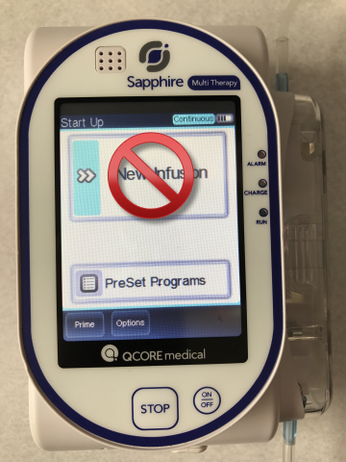
How do I prepare the tubing?
- Turn the pump on by pressing the [ON/OFF] hard key in lower right corner.
- Press [PreSet Programs] on the pump screen (see Figure 1).
- Select desired preset program on screen (review the pump program with the medication label).
- Press [OK].
- Attach the filtered extension set to the Sapphire® pump tubing as follows:
  - Remove end cap from the Sapphire® pump tubing
Figure 1
  - Remove end cap from the shorter end of the filtered extension set tubing and connect to the open end of the Sapphire® tubing.
  - Twist cuff from Sapphire® tubing onto the filtered extension set.
Add back check valve here
Connect Sapphire® pump tubing set here
Filter
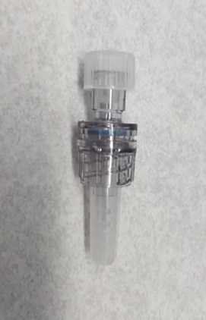
Hold here
- Attach back check valve to filtered extension set tubing as follows:
Remove cap and connect to tubing
- Remove back check valve from package by holding clear center piece.
Back check valve
- Take cap off the end of the filtered extension tubing.
- Remove short, round cap on the end of back check valve and connect to open end of the filtered extension tubing.
- Twist cuff from filtered extension tubing onto the back check valve.
- Open the safety door on the Sapphire® pump. Using your thumb, press safety door outwards.
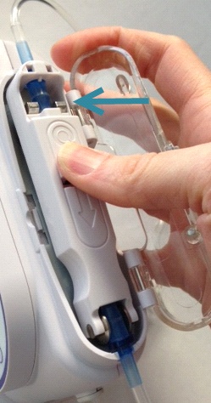
- Insert the IV tubing cassette into the pump by placing the saddle on the round metal anchor (Figure 2) and clipping the upper end of the cassette into the metal lock (Figure 3).
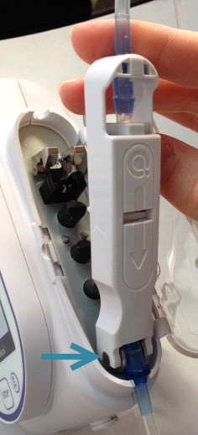

METAL LOCK

SADDLE

Figure 3
Figure 2

- Close the safety door and ensure that it clicks upon closure.
- Spike the IV bag with the pump tubing as follows:
- Remove the tab on the IV bag.
- Keeping the spike sterile, remove the spike cover from the IV tubing. Do not touch the spike.
- Hold the port of the IV bag straight and insert the spike by pushing and twisting at the same time.
- Prime (fill with fluid) and remove the air from the IV tubing as follows:
- Loosen the cap, being careful not to remove it, at the end of the back check valve.
- Press [PRIME] in the lower left corner of the screen (Figure 4). The pump will prompt you to be sure that the tubing is NOT connected to the patient’s catheter (Figure 5).
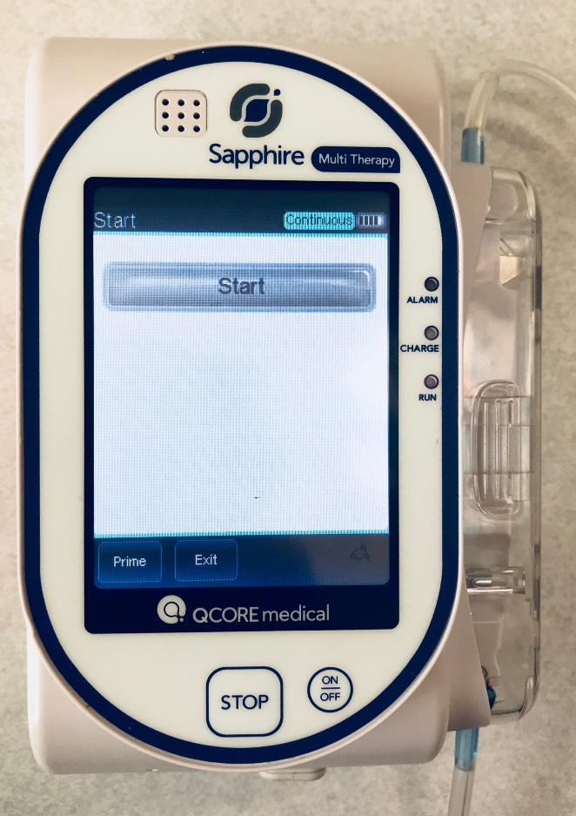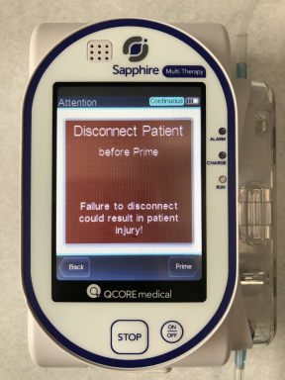
Figure 5
Figure 4

c. Press [Prime] again and the pump will begin to prime (fill the tubing) with
IV solution. If there is a filter in the tubing, hold pointed end in an upward
direction while priming until fully filled with fluid.
d. Once the pump has stopped priming, check to be sure that the IV set is
filled with fluid and no air remains. If not, repeat the priming steps.
- Once you stop priming, the pump screen will prompt you to “connect set to
patient after prime”. Press [OK].

How do I give the medication?
- Check your catheter cap to make sure it is on securely. Always hold your catheter cap while connecting/disconnecting to prevent accidental removal.
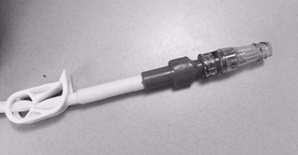
- Unclamp your catheter and remove the green alcohol cap.
Valved IV catheter cap
- Vigorously scrub the end of the cap on your catheter with an alcohol pad for 15 seconds.
- Flush your IV catheter with saline as follows:
- Hold the prefilled saline syringe upright.
- Do not remove the cap and press forward on the plunger to break the seal. Do not pull back on the plunger.
- Gently tap the sides of the syringe so the bubbles rise to the top. Remove
the cap and push the plunger to remove all the air.
- Push and twist the saline syringe into your catheter cap to the right until
secure.
- Inject the saline solution.
- Remove and discard syringe in your trash.
- Vigorously scrub the end of the cap on your catheter with an alcohol pad for 15 seconds.
- Remove and discard the protective cap from the end of IV tubing.
- Push and twist the end of IV tubing into your catheter cap to the right until secure.
- Make sure all clamps on your catheter and IV tubing are open.
- Press [Start] on the screen to begin the infusion.
- Press [Lock] then [Patient lockout] on the screen.
- Screen will darken after 30 seconds.
- The run light will continue to flash green.
- To “wake up” the screen, press the on/off button once, and after a brief pause the screen will light up.
- Place the IV bag and pump into the backpack/fanny pack or use the IV pole.

How do I stop the medication when my dose is done?
- Pump screen will display “Infusion Complete”. Press [Mute] then [OK] on screen.
- Press [Press to unlock patient] on screen.
- Keypad appears. Enter password “8880”.
- Press [OK] on screen.
- Screen will display “Authorization level Medium”. Press [OK] again.
- Turn pump off using the hard [ON/OFF] key on pump.
- Screen will display “Press OFF to turn off the pump”. Press [OFF] on screen.
- Wash your hands.
- Disconnect the IV tubing from your catheter and place a new white cap on the end of the tubing and keep empty bag attached (this will keep the tubing sterile for reuse).
- See next section to learn how to reuse tubing for your next dose.
- Vigorously scrub the end of the cap on your catheter with an alcohol pad for 15 seconds.
- Flush your IV catheter with saline (See page 6; step 4).
- Vigorously scrub the end of the cap on your catheter with an alcohol pad for 15 seconds.
- Flush your IV catheter with heparin as follows:
- Hold the prefilled heparin syringe upright, press forward on the plunger, remove the cap, and push out the air.
- Push and twist the heparin syringe into your catheter cap to the right until secure.
- Inject the heparin leaving a small amount of solution in the syringe, and clamp your catheter before removing the syringe, then discard in your trash.
- Place a new alcohol cap on the end of your IV catheter cap.

- If you need to change the tubing for your next dose, refer to section “How do I change my IV tubing?” (See page 9).

How do I reuse the tubing for the next dose?
Change your IV tubing every 3 days or as directed by your nurse or pharmacist. Labels will be provided to help you keep track. To reuse your tubing, do the following:
- Clean your work surface or laminate mat with household disinfectant. Let the area air dry.
- Wash your hands.
- Open the backpack/fanny pack and place the empty IV bag and pump on the work area.
- Remove the tab from the new IV medication bag.
- Remove the spike from the old IV bag. Do not touch the spike.
- Insert the IV tubing spike into the new IV medication bag by using a twisting/pushing motion.
- Turn the pump on by pressing the [ON/OFF] hard key in lower right corner.
- Press [PreSet Programs] on the pump screen (Figure 6).
Figure 6

- Select desired preset program on screen (review
the pump program with the medication label).
- Press [OK].
- Follow steps under “How do I give the medication?” (See page 6).

How do I change the IV tubing?
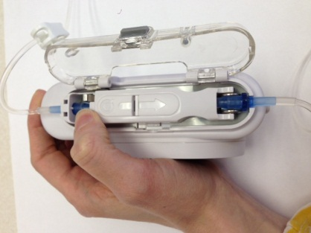
Always use a new medication bag when changing tubing. Change and throw away your IV tubing every 3 days or as directed by your nurse or pharmacist.
METAL LOCK LOCK
- Open the safety door.
- Remove the tubing cassette by raising the metal lock that secures it to the pump (Figure 6).
- Throw away tubing.
- Follow steps 1-12 under “How do I prepare the tubing?” (See pages 3-5).
Figure 6

What do I do if the pump alarms?
When an alarm sounds, the pump will immediately provide a message with the error and suggested solution.
- Press [Mute].
- Follow the suggested solutions and then press [OK]
- Press [Press to unlock patient] on screen.
- Keypad appears. Enter password “8880”.
- Press [OK] on screen.
- Screen will display “Authorization level Medium”. Press [OK].
- Press [Request Continue] then [OK] to restart the infusion.
- Press [Lock] then [Patient lockout].
- Contact HomeMed if you are unable to resolve the alarm.

What do I do if there is air in the IV tubing?
If you need to remove air from the IV tubing do the following:
- Press [Mute] and then [OK] if the pump is alarming.
- Press [Press to unlock patient] on screen.
- Keypad appears. Enter password “8880”.
- Press [OK] on screen.
- Screen will display “Authorization level Medium”. Press [OK] again.
- Disconnect the IV tubing from the patient keeping the end of the tubing sterile. You will need to change the tubing if it is dropped or touches any unsterile object.
- Press [Prime]. The pump screen will remind you to disconnect from the patient.
- Press [Prime]. Once all the air is removed, press [Finish Prime] then [OK].
- Vigorously scrub the end of the cap on your catheter with an alcohol pad for 15 seconds.
- Push and twist the end of IV tubing into your catheter cap to the right until secure.
11.Press [Request Continue] then [OK] to restart the infusion.

12.Press [Lock] then [Patient lockout].

How do I care for the infusion pump?
- Do not place your pump in any fluids or cleaning solutions.
- Avoid dropping or hitting your pump. Always recheck the program if you drop or hit your pump.
- Never use sharp objects such as pens, pencils, fingernails or paper clips to clean your pump.
- If needed, clean your pump using an alcohol wipe or a soft cloth dampened with a mild soap and water.
- You may wash the backpack/fanny pack in your washing machine and dry under low heat in your dryer.
- Never use the pump in the presence of flammable or explosive vapors.
- Avoid exposing pump to extreme temperatures.
- Always avoid sources of high intensity electromagnetic radiation such as x-ray machines.

How do I charge the battery?
Charge your pump battery at least 4 hours every day. The pump can operate while it is being charged. To preserve battery life, charge the pump whenever possible.
Charge the battery as follows:
- With the white arrows facing up, plug the plastic end of the power supply cord into the Sapphire® pump power socket. If you were supplied with a pump cradle, plug the cord into the bottom of the cradle.
- Plug the other end of the power supply cord into a wall outlet.
- On the front of the pump, verify that the Charge LED status indicator is ON (blinking yellow light). The yellow LED will remain lit when battery is fully charged.
- An alarm is triggered when there are 30 minutes left until battery depletion.
- If the “Battery Depletion” alarm sounds, immediately connect the pump to the wall outlet using the power supply cord.
- If you have a backup pump, assure it is fully charged and functional (by alternating use with tubing changes).

How can I remember the steps?
Follow S-A-S-H when you give the medication:
S - saline flush
A - administer medication
S - saline flush
H - heparin flush

What if I still have questions?
- For on-line video and resources, please visit: https://homecare.med.umich.edu/HomeMed/Patient-Resources
- Call HomeMed. Our 24-hour number is 800-862-2731.
- Please identify yourself to the hospital operator as a HomeMed patient.

In summary: These are the steps to follow when you give your IV medication with the Sapphire® pump:
- Wash your hands
- Turn pump on and review program
- Attach the filtered extension set to the Sapphire® pump tubing
- Attach back check valve to filtered extension set tubing
- Place IV tubing into pump
- Spike bag
- Prime tubing with fluid
- Flush your IV catheter with saline
- Start infusion
- Stop infusion. Keep tubing sterile for reuse (3 days)
- Flush your IV catheter with saline
- Flush your IV catheter with heparin
- Place a new alcohol cap on catheter

Disclaimer: This document contains information and/or instructional materials developed by Michigan Medicine for the typical patient with your condition. It may include links to online content that was not created by Michigan Medicine and for which Michigan Medicine does not assume responsibility. It does not replace medical advice from your health care provider because your experience may differ from that of the typical patient. Talk to your health care provider if you have any questions about this document, your condition or your treatment plan.
Patient Education by Michigan Medicine is licensed under a Creative Commons Attribution-NonCommercial-ShareAlike 4.0 International Public License. Last Revised 12/2024

