Using an Enteralite® Infinity® Feeding Pump

HomeMed



Table of Contents:
Key Points……..........................................................................3
How do I use the Enteralite® Infinity® pump?…….......4-8
How long can the formula hang? ……................................9
Battery Information…….......................................................10
How do I clean the pump?……...........................................11
Pump safety…….....................................................................12
Troubleshooting the Enteralite® Infinity® Pump…..13-17
What do I do in the event of pump failure or power outage?……..............................................................................18
How do I use the syringe feeding method?……............18
How do I use gravity administration?……................19-20
To view the Infinity pump training video, please visit the following web link or scan the QR code below.
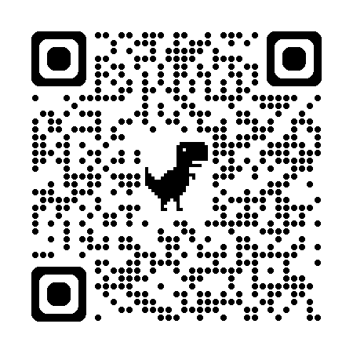
- https://homecare.med.umich.edu/HomeMed/Patient-Resources/Infinity-Pump

Key points to remember when using an Enteralite® Infinity® pump:

- Wash your hands with soap and water before handling your feeding tube and supplies.

- If you have more than one catheter (example: feeding tube and intravenous), always double check to make sure you are infusing your formula into the feeding tube and not into the IV line.

- Use a new Enteralite® Infinity® feeding set each day.

- You may save your last feeding bag and reuse it for one additional day if you have not received your delivery yet. Please contact HomeMed 3-4 days in advance if you think you are going to run out of feeding bags.

- In case of a pump failure or power outage, refer to page 18 for instructions.

- Store supplies and formula in a dry, clean area.

- Do not use supplies if the seal is broken, the package is torn, or the inside or outside of the package is wet.

- Check your formula for expiration dates. Do not use formula if the expiration date has passed. See page 9 for instructions on how much formula you can add to the bag each time you fill.

- Clean your pump weekly to avoid frequent errors (see page 11).

- Keep your pump plugged into a wall outlet as much as possible.

- Unless otherwise directed, never mix your medications in with the formula. Medicine that needs to be put in your feeding tube should be given separately with a syringe.
How do I use the Enteralite® Infinity® Pump?

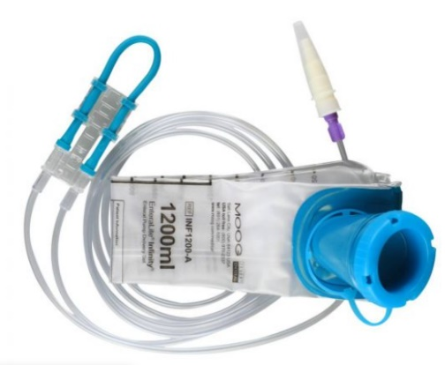
If you view online instructions by Zevex on how to use the Enteralite® Infinity® pump, you will notice some differences in our steps below. We designed these instructions to make setting up the pump as easy as possible.

Step 1: Prepare the feeding set
- Place your feeding set on a clean surface.

- Prepare your formula as shown to you by a clinician.
Note: If you blenderize your formula, let the mixture stand for 10 to 15 minutes before adding to the feeding set. This will decrease the chance of an alarm due to air in the tubing.
- Open the plastic cap of the feeding set and pour the formula into the bag. Ask your nutritionist how much formula to add to the feeding bag at a time. Formula can spoil if it hangs in the bag too long.

- Remove the excess air from the bag by squeezing the formula.
to the top of the plastic rim before closing the plastic cap.

- Remove the plastic protector from the end of the feeding set.

- Hang the bag on the IV pole so the bottom of the bag is just above the pump.

Step 2: Attach the feeding set to the pump
- Press the tab on the front of the pump door and lift up the door.

- To load the tubing into the pump, hold the cassette so the clear plastic portion faces toward you and the loop of tubing is to the left (Figure 1). Loop the blue tubing around the wheel of the pump and stretch it slightly to the right.

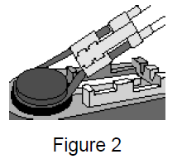
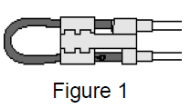
- The plastic portion should drop into place. (Figure 2).

- Close the lid by pressing the tab in until the latch clicks into place.
Step 3: Prime the tubing
- The feeding set must be primed with formula before connecting it to the feeding tube.

- Press and hold the “on/off” button for 2 seconds. The pump will beep and run through a short self-test.

- Press and hold the “prime” key until the formula reaches the end of the tip on the feeding set.

Step 4: Program the pump
- When you turn on the pump, it should be at the rate screen. The word “rate” should be displayed in the lower left corner of the screen. If not, press the “rate/dose” key until “rate” appears. Then press the + key until the desired rate is shown on the screen. The rate is the speed at which the formula is infused (mL/hour). This is different than the dose.

- Press the “rate/dose” key to display dose in the lower left corner of the screen. It should read INF. If INF is not displayed, then press and hold the + key until INF appears on the screen (INF will appear on the screen after the dose reaches 3000). INF stands for “infuse” which allows the pump to deliver the entire amount of formula that was put in the bag.

- You will not be using the “feed interval” function and it should always be set to “none”. Press the “feed int” key, and then press the “clear” key. The screen will read “none”.

- The “vol/total” key keeps track of how much formula has been delivered. It is not necessary to use this key since you are not setting a dose. If you push this button, you can press “rate/dose” to return to the “rate” screen.
Step 5: Run the pump
- Connect the tip of the feeding set to the patient’s feeding tube.

- Press the “run/pause” key. The word run will appear in the upper right hand corner of the screen with an arc moving around it to indicate the pump is delivering formula.

- When the feeding is finished, press the “on/off” key to turn the pump off.

Step 6: Rinse the feeding set
If you need to continue your feeding, the feeding set should be rinsed out before you add more formula (the same feeding bag should be used for 24 hours).
- Before refilling the bag, disconnect the feeding set from the patient’s feeding tube and remove the tubing from the pump.

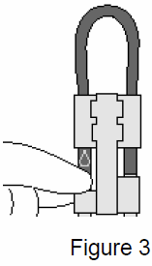
- Place some hot water in the bag, shake well, and dump out (repeat if necessary).

- Place more hot water in the bag and snap the cap closed.

- Locate the droplet symbol on the blue tubing. Gently pinch the tubing right below the droplet symbol (Figure 3). This will allow the water to flow through the tubing.

- While pinching the tubing, squeeze the bag to force water through the tubing until the water runs clear.

- To continue feeding start at Step 1. If you are not going to restart the feeding right away, store the bag in an airtight container.

NOTE: The feeding set can also be rinsed by disconnecting the feeding set from the patient and pouring hot water into the bag. Hold the end of the feeding set over a sink and use the “prime” key to push the water through the tubing. Repeat until the feeding set is clear. To continue feeding, start at Step 1.

How long can the formula hang?
- Formula may spoil if it is left at room temperature for too long after being opened.
- Different types of formula have different hang times.
- Only add enough formula to the feeding bag so it does not hang longer than recommended (see below).

Type of formula | Maximum Hang Time
Ready-to-feed liquid formula in a can | 8 hours
Ready-to-feed liquid formula in a can plus added water, oils, protein, carbohydrate, or electrolytes | 4 hours
Powder or liquid concentrate formula with added water | 4 hours
Breastmilk | 4 hours (less is better)
Breastmilk plus calorie booster | 2 hours

To figure out how much formula you can add to your bag each time you refill, use this simple calculation:
rate x maximum hang time = mL of formula you can add to the bag
 | Example: | Your formula:
Rate: | 40 mL/hr
Maximum hang time: | 4 hours: (powdered formula and water)
Total: | 160 mL of formula to bag

Always rinse out the feeding bag and tubing with water before adding more formula.

Battery Information
- Keep the pump plugged into a wall outlet when not in use to keep the battery fully charged. The pump will charge whether it is turned off or running. When the pump is plugged into a wall outlet and is recharging, a plug icon will appear in the lower right hand corner and bars will move on the fuel gauge from E to F.

- The pump can be fully recharged in 6 hours. When fully charged, the pump will run for 24 hours if the pump is running less than a rate of 125 mL/hour.

- When the pump is operating on the battery, a battery icon will appear in the lower right hand corner. Each bar on the fuel gauge represents about 6 hours of battery charge.

- When there is only 1 hour of charge time left, the pump will alarm “low batt” indicating that the pump needs to be plugged into a wall outlet.

- If the pump completely shuts down from a depleted battery, it will need to be plugged in for at least 10 minutes before turning it on again.
  - Keep the pump plugged in until fully recharged. If the pump is plugged in for less than 10 minutes after the battery is depleted, an error will occur.
  - Turn off the pump to clear the alarm and allow to recharge for at least 10 minutes before turning on.

How do I clean the pump?
- Turn off the pump and unplug from the outlet before cleaning.

- Clean the pump at least one time per week or whenever anything is spilled on it.

- Use warm soapy (dish soap) water and a soft sponge or cloth to wipe the pump. You may use a cotton swab to gently clean the tubing pathways inside the door.

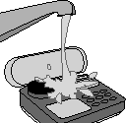
- Rinse the pump by holding it under a stream of warm water. Do not immerse the pump in water.

- Dry the pump after cleaning with a clean cloth.

Key points:
- Never use sharp objects (fingernails, pens or pencils, paper clips, or needles) to clean the pump.
- Do not use alcohol or harsh disinfectants for cleaning.
- The Enteralite® Infinity® carry packs are machine-washable. Use cold water and gentle cycle. Hang to dry.

Pump safety
- Avoid dropping or hitting the pump. If the pump is dropped, always recheck the pump to be sure it is still infusing correctly.

- Electromagnetic emissions may affect the operation of the feeding pump. However, the Enteralite® Infinity® will not be affected by most sources. Possible sources of interference include: cell phones, cordless telephones, microwave ovens, security systems, etc. If an electromagnetic device is used within one yard of the Enteralite® Infinity®, the pump may automatically shut off and lose the saved settings.

Travel
  - If you plan to travel for an extended period of time, please make sure you are prepared in advance with enough supplies to take with you.

  - If you use a pump to give your feedings and you are traveling out of state, we may be able to provide you with a back-up pump to take with you.

  - If you will be taking your feeding pump on an airplane, please call HomeMed for further instructions.

Troubleshooting the Enteralite® Infinity® Pump
For all pump alarms, press the “run/pause” key to silence the alarm, then identify and correct the problem and press the “run/pause” key again to restart the pump.
Alarm: | Probable cause: | How to fix:
Load set | - Feeding set has not been placed properly into pump.  - Possible crack in door or broken tab inside door. | - Check to make sure feeding set has been properly placed into pump and that the door is closed.  - Check to make sure the pump is clean, especially where the cassette is loaded.  - Check to make sure the proper type of tubing is in the pump. May need to use a new feeding set.  - Check door for cracks or broken tab. Call HomeMed for pump replacement if cracks found.
No flow in    (see note below) | - There are kinks or formula clumps in the tubing between the bag and the pump. | - Check to make sure the pump is clean, especially where the cassette is loaded.  - Correct by following the steps on the next page.

Alarm: | Probable cause: | How to fix:
No flow out  (see note below) | - There are kinks or blockages between the pump and the  patient’s feeding tube.  - The patient’s feeding tube may be clogged. | - Check to make sure the pump is clean, especially where the cassette is loaded.  - Correct by following the steps below.  - Unclog the patient’s feeding tube as directed by your doctor’s office or a HomeMed nutritionist.

Note: Do not press the “prime” key for “no flow in” or “no flow out” errors - This may cause the pump to malfunction. The pump may appear to be running, but formula may not infuse.

If these errors happen follow these instructions:
- Remove the cassette from the pump.

- Clear the occlusion (kink or blockage).

- Reinsert the cassette into the pump and press run.

- Before connecting to patient, verify that formula is dripping from the end.

- Reconnect to patient and resume feeding.

Alarm: | Probable cause: | How to fix:
No food | - Feeding bag is empty.  - Air is trapped in the cassette or tubing. | - Rinse the feeding bag with water and refill with formula if feedings are to continue. Replace the feeding bag if it has been 24 hours since last changed.  - Disconnect the feeding bag tubing from the patient and press the “prime” key until the air bubbles have moved out of the tubing.  - Check to make sure the pump is clean, especially where the cassette is loaded.  - Check to make sure feeding set has been properly placed into pump and that the door is closed.
Push run to feed | - The pump has been in the pause mode for more than two minutes. | - Press the “run/pause” key to silence the alarm. Press the “run/pause” key again to restart feedings or press the “on/off” key to turn the pump off.
Shut door | - The pump door has been opened while the pump was running. | - Press the “run/pause” key to silence the alarm. Close the door until the latch clicks into place. Press the “run/pause” key to restart the feedings.

Alarm: | Probable cause: |  | How to fix:
To stop let go | - Priming. |  | - When pressing and holding the “prime” key, alarm will sound once, pump will begin pumping at maximum rate of 600 mL/hour and display “to stop let go”. Release the “prime” key when done priming.
Dose done |  | The preset dose of formula has been delivered. | - Most patients do not use the dose function. Not using the dose function allows the pump to run until it has emptied all the formula from the bag. To do this, the dose is set to INF which will appear on the screen after the dose scrolls past 3000.
Next dose |  | The pump is set to interval mode and is between feedings. | - Most patients do not use the interval function. If the screen reads “feed interval”, press the “feed int” key then press the “clear” key. The screen will read “none”.
Chek |  | The pump is in interval mode and the programmed rate, dose and feeding interval are not compatible. | - Most patients do not use the interval function. If the screen reads “feed interval”, press the “feed int” key then press the “clear” key. The screen will read “none”.

Alarm: | Probable cause: | How to fix:
Low batt | The battery charge is low. | - There is approximately 1 hour of charge left on the battery. See page 10 for battery charging information.
ER01 – ER99 ERRA  ERRZ | Internal error. | - If any of these errors occur, turn the pump off and then back on. If the error does not clear, call HomeMed for instructions.

What do I do in the event of pump failure or power outage?
Use one of the non-electric feeding methods:
- Feeding with a syringe (page 18)

- Feeding with a gravity bag using hourly rate calculations (pages 19-20)

Note: Children with small bowel feedings will not be provided with a gravity bag. Please refer to syringe feeding instructions on page 18 for back-up.

How do I use the syringe feeding method?
- Wash your hands with soap and water.

- Flush feeding tube with water before the feeding.

- Prepare your formula as instructed by your HomeMed clinician.
  - Using a syringe, pull up ¼ of the hourly rate of formula.
  - Slowly push into the feeding tube.
  - Repeat the process every 15 minutes. For example, if the pump rate is 20 mL/hr, slowly administer 5 mL every 15 minutes.

- Flush the feeding tube with water after the formula has been given.
- If the volume is well tolerated, try giving half the volume of formula every 30 minutes.
- If formula is usually given at night, you can give the syringe feedings during the following day.

How do I use gravity administration?

The Enteralite® Infinity® feeding set will not run by gravity. Please use the gravity feeding set that was sent in your first delivery. To use your gravity bag, follow the instructions be low or scan the QR code to watch a gravity feeding training video.
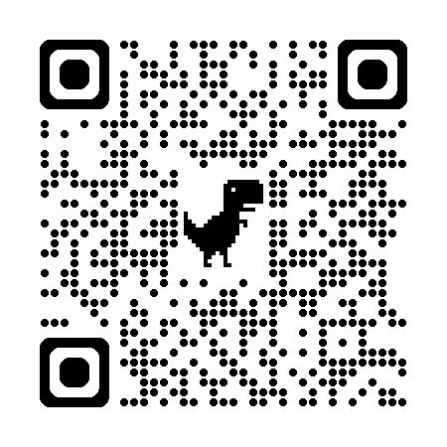
- Note: Children with small bowel feedings should refer to syringe feeding instructions on page 18.

Gather the following supplies:
  - Gravity tube feeding bag
  - Formula
  - A cup of warm water
  - Syringe for flushing

Setting up:
- Wash your hands with soap and water.

- Flush your feeding tube with the prescribed amount of water.

- Prepare your formula as instructed by your HomeMed clinician.

- Be sure the roller clamp on the tube feeding bag is closed (roll the wheel all the way down).

- Pour 1-2 cans of formula into the feeding bag.

- Place the feeding bag above the level of your chest and stomach. Use something secure, such as an IV pole.

- To prime the tubing:
- Squeeze and release the drip chamber until the formula fills to the line etched in the chamber.
- Open the roller clamp to allow the formula to flow to the end of the tubing.
- Close the roller clamp.

- Insert the end of the feeding bag into your feeding tube, unroll the roller clamp and allow formula to flow until the feeding bag is empty (refer to the chart below for rate calculations).

- Flush your feeding tube with the prescribed amount of water.

Example of gravity bag administration with hourly rate calculations
You can control how fast your formula is administered by gravity by adjusting the roller clamp. Watch the drip chamber and time the drips according to the calculations below.

If pump rate is: | Drop rate should be:
60 ml per hour | 4 drops every 15 seconds
80 ml per hour | 5 drops every 15 seconds
100 ml per hour | 6 drops every 15 seconds
120 ml per hour | 7 drops every 15 seconds
140 ml per hour | 8 drops every 15 seconds

Disclaimer: This document contains information and/or instructional materials developed by the Michigan Medicine for the typical patient with your condition. It may include links to online content that was not created by Michigan Medicine and for which Michigan Medicine does not assume responsibility. It does not replace medical advice from your health care provider because your experience may differ from that of the typical patient. Talk to your health care provider if you have any questions about this document, your condition or your treatment plan.

Author: HomeMed Patient Education Committee
Last Revised 10/2021

Patient Education by Michigan Medicine is licensed under a Creative Commons Attribution-NonCommercial-ShareAlike 4.0 International Public License.

