Using a Kangaroo OMNI™ Feeding Pump

HomeMed



Table of Contents:

Key points for using the Kangaroo OMNI™ pump.........3
How to use the Kangaroo OMNI™ pump...........................4
Steps for using the pump.....................................................4
Pump icon meanings.............................................................9
Locking the screen.................................................................9
Formula hang times............................................................10
Battery information.............................................................11
Attaching the pole clamp...................................................12
Cleaning the pump..............................................................12
Keeping the pump working safely...................................13
Traveling with the pump...................................................13
Troubleshooting issues with the Kangaroo OMNI™ pump.........................................................................................14
What to do if the pump isn’t working or if the power goes out.................................................................................17
Other feeding options...........................................................18
Syringe feeding....................................................................18
Gravity bag feeding.............................................................19
To view the OMNI pump training video, please visit the following web link or use the QR code.
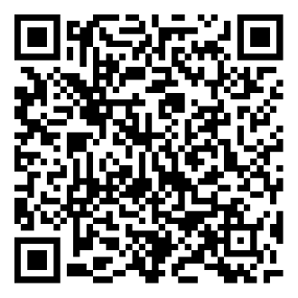
  - https://homecare.med.umich.edu/HomeMed/Patient-Resources/Omni-Pump

Key points for using the Kangaroo OMNI™ pump
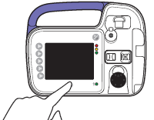
- Wash your hands with antibacterial soap before using your feeding tube and supplies.
- If you have more than one catheter (for example, you have a feeding tube and IV), always make sure you are putting the formula into the feeding tube and not into the IV (intravenous) line.
- Use a new Kangaroo OMNI™ feeding bag (also called a feeding set, or set) each day unless your provider tells you to do something differently.
- You may save your last feeding bag and reuse it for several days if you have not received your delivery yet. Please contact HomeMed 3-4 days in advance if you think you are going to run out of feeding bags. If the pump will not work or if the power goes out, use another feeding option (such as syringe feeding or gravity bag feeding).
- Keep your pump supplies and formula in a dry, clean area.
- Do not use supplies if the seal is broken, the package is torn, or the inside or outside of the package is wet.
- Check your formula for expiration dates. Do not use formula if the expiration date has passed. Read the section on formula hang times for instructions on how much formula you can add to the bag each feeding.
- Keep your pump plugged into the wall outlet as much as possible.
- Never mix medications into the formula unless your doctor has told you to. You should take your medications separately, by administering them through your tube with a syringe.
- Clean your pump daily to keep the pump working correctly (read the pump cleaning instructions section for more details).


How to use the Kangaroo OMNI™ pump
To choose the functions on the pump, push the buttons along the left side of the pump.

Step 1: Prepare the feeding bag
- Place your feeding bag on a clean surface.
- Pull open the plastic cap of the feeding bag and pour the formula into the bag. Close the cap by pushing down on the top and fastening the tab.
- Ask your dietitian how much formula to add to the feeding bag at a time. Formula can spoil if it hangs in the bag too long.
- If you blenderize your formula, wait 10-15 minutes after blending before adding it to the feeding bag. This will decrease the chance of one of the pump alarms going off because of air in the tubing.
- Hang the bag on the IV pole so the bottom of the formula line in the bag is about 10 inches above the pump.
- Remove the plastic protector from the end of the feeding set tubing. You may store the protector on the right side of the pump in the built-in ENFit cap storage.

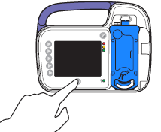
Step 2: Turn on the pump
- Press the power button  . The pump will beep and show a kangaroo jumping across the screen.
- The pump will display “PRIOR SETTINGS” at the top of the screen.
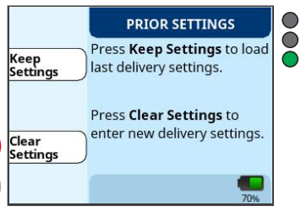
- If this if your first time using the pump, choose “Clear Settings.” If you have already programmed your pump before this, choose “Keep Settings.”
- The screen will now display “LOAD SET.”

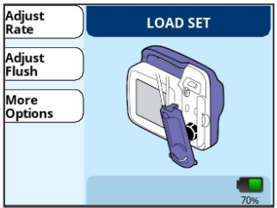
Step 3: Install the feeding set cassette
- Follow the animated instructions on the screen to load the cassette into the pump. You will loop the bottom of the cassette around the black wheel, pull up slightly, and push in gently to click the cassette into place.

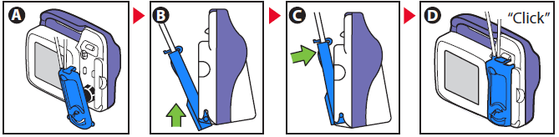
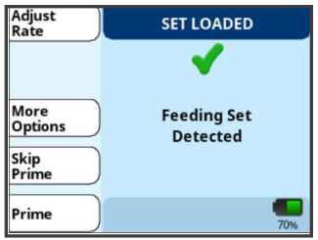
- If you have correctly installed the cassette, the pump screen will display “SET LOADED” across the top of the screen.
- Note: If you have loaded the pump correctly and it continues to show “LOAD SET,” you may have a defective (non-working) feeding bag. Read more about this in the troubleshooting section.

Step 4: Prime the tubing
You must prime the feeding set tubing with formula before connecting it to your feeding tube. Priming means running the formula through the feeding set to get rid of air.
- Choose “Prime” from the “SET LOADED” screen.
- If your tubing is already primed, you may have another option to “Skip Prime.” Only skip the prime if you are certain there are no air bubbles in the feeding set tubing.
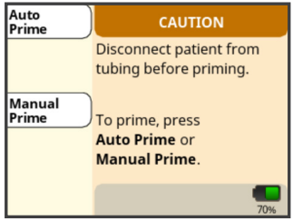
- Choose “Auto Prime” and the pump will fill the tubing with formula.
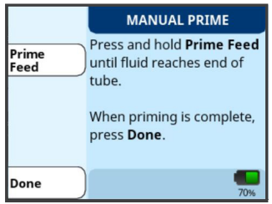
- If you don’t want to use the Auto Prime function, you may choose “Manual Prime” and then pressing and holding the “Prime Feed” option until the formula drips from the end of the feeding set tubing.
- If the formula does not reach all the way to the end of the tubing with the Auto Prime, you must press and hold “Prime Feed” until the formula drips from the end of the feeding set tubing.
- Once the feeding set tubing has no air in it, choose “Done.”

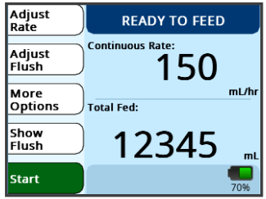
Step 5: Program the pump’s feed rate

If you have already programmed your pump before this use, check to make sure the continuous rate displayed on your screen is the correct rate for the feeding. If it is correct, you may skip this step.
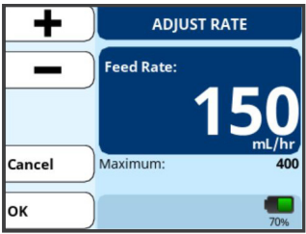
- Choose “Adjust Rate.”
- Use the + and – buttons to increase or decrease the rate. You can press and hold the buttons for quicker programming.
- Choose “OK” when you have the correct rate entered.

Step 6: Run the pump
- Connect the purple tip of the feeding set to the patient’s feeding tube.
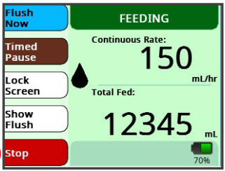
- Choose “Start” and the pump will begin infusing your formula. The pump will now show “FEEDING” at the top of the screen. A picture of a drop will start moving down the screen. This means that the pump is running.
- If you need to pause or stop the feeding at any time, you may choose “Stop” or “Timed Pause.”
- “Stop” will pause the feeding and return you to the “READY TO FEED” screen. If you do not restart the feed within 10 minutes of choosing “Stop,” an alarm will sound and prompt you to continue the feed.
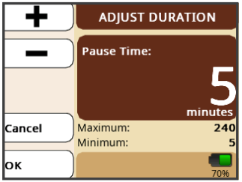
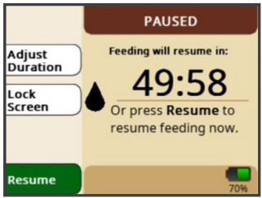
- “Timed Pause” will allow you to temporarily pause the feed. You can choose an amount of time between 5-240 minutes to pause the feed by choosing “Adjust Duration” and using the + and – buttons to adjust the time. If you would like to restart the feeding before the timed pause is completed, choose “Resume.” Be aware that when the pause duration ends, the feeding pump will automatically restart the feed. If you do not want the feed to automatically restart, consider using the “Stop” function instead of “Timed Pause.”
- When the feeding is done, press and hold the power button (which looks like this: ) until the pump shuts off.
- Throw the bag out if it has been used for 24 hours (unless your provider told you to do something differently).
- If you are going to restart your feeding right away with the same bag, leave the tubing in the pump while you rinse it out (see details below).

Step 7: Rinse the feeding bag
You should rinse your feeding bag with water before you add more formula, or if you are going to save the bag to use later. Use the same feeding bag for 24 hours unless your provider told you to do something differently.

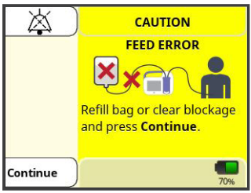
Follow these instructions to rinse the feeding bag and tubing:
- When the bag is empty, the pump will show “FEED ERROR.”
- Remove the purple end of the feeding bag from your feeding tube.
- Pour about 1 cup of warm water (no soap) into the feeding bag. Then close the top and shake the bag. Open the top and dump the water out into the sink. Repeat 2-3 times or until the water and the bag are clear.
- To rinse the tubing part of the feeding set, add another small amount of warm water to the bag.
- Press “Continue,” then “Prime.”
- Hold the purple end of the tubing over a sink or cup and “prime” all the water through the tubing to rinse it. You will be using the “Prime Feed” button under the “Manual Prime” screen.
- If you are going to continue feeding, start back at “Step 1: Prepare the feeding bag” in this handout. If you are not going to restart the feeding right away, you can hang the feeding set on the IV pole until your next scheduled feeding.

What other Kangaroo OMNI™ pump features should I be aware of?

The “More Options” button
- The “More Options” button will allow you to clear the “total fed” amount, view your feeding history, change the device’s sound (“Audio”) volume, and change the screen brightness.
- Under “More Options,” you should always keep “Intermittent Mode” off and keep “Feed Complete Audio” on.

Can I lock the pump settings?

While the pump is running, you can lock the input screen to prevent accidental button presses. This is especially helpful when using the pump backpack.
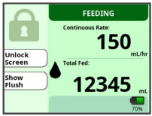
- To lock the screen, press and hold the “Lock Screen” button for 5 seconds. A countdown will appear to show how long to hold the button and a lock symbol will appear on the screen once the lock screen has been activated. The lock function will disable the buttons.
- To unlock the screen, press and hold the “Unlock Screen” button for 5 seconds. A countdown will appear to show how long to hold the button and the lock symbol will disappear once the buttons have been re-enabled.

Icon meanings
You may see these icons at the bottom of the pump screen while your feed is running.

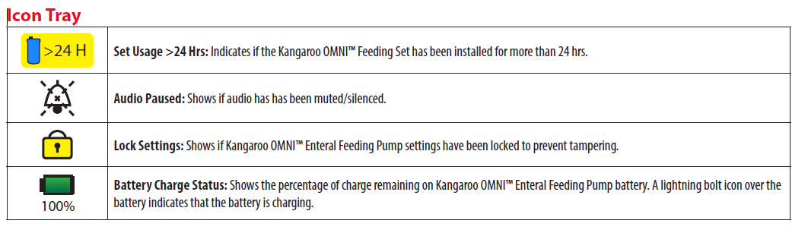

How long can the formula hang in the feeding bag?
Formula may spoil (go bad) if it’s left at room temperature for too long after being opened. Different types of formulas have different hang times. Hang time is the amount of time your formula may be stored at room temperature before too many bacteria grow and it spoils.
- Only add enough formula for your pump tube feeding to your bag so that it does not hang longer than recommended. Details about hang times for different formulas, as well as how to figure out how much formula you need, are included below.
- Always rinse out the feeding bag and tubing with water before adding more formula, so that the newly added formula does not mix with any “old” formula.

Type of formula | Maximum hang time
Formula straight from the container | 8 hours
Formula mixed with water, powders, or other liquids | 4 hours
Breastmilk | 4 hours
Homemade blenderized feeds | 2 hours

To figure out how much formula you can add to your bag each time you refill, use this calculation: Pump rate (in mL/hr) multiplied by the maximum hang time (in hours) = mL of formula you can add to the bag.
- Example: If your pump rate is 60 mL/hr, and you use formula straight from the container (which has an 8-hour hang time), you can add 480 mL of formula to the bag (60 x 8 = 480).

What do I need to know about the pump battery?
- Keep the pump plugged into a wall outlet whenever possible to keep the battery fully charged. The pump will charge whether it is turned off or running.
- When using the power cord, make sure the cord adaptor is pushed all the way into the back of the pump for proper charging.
- The battery life depends on your pump rate. With a full charge, the battery will last for:
  - 18 hours at 400 mL pump rate
  - 20 hours at 125 mL/hr pump rate
  - 23 hours at 50 mL/hr pump rate
- It takes about 12 hours for the battery to fully re-charge.
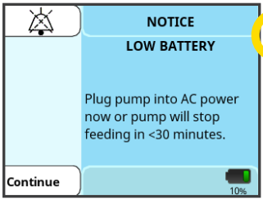
- The pump shows a battery icon in the lower right corner of the screen to tell you how much battery life is left. A totally green battery icon means that the battery is fully charged.
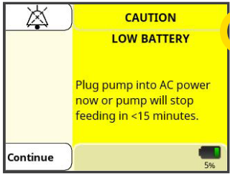
- The pump will display “LOW BATTERY” with a blue background when there is about 30 minutes of battery life left. You may continue to run the pump if you plug the power cord into an outlet.
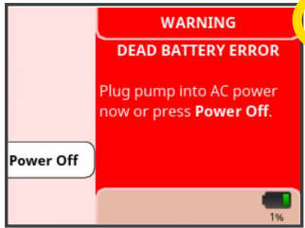
- The pump will display “LOW BATTERY” with a yellow background when there is about 15 minutes of battery life left. You may continue to run the pump if you plug the power cord into an outlet.
- The pump will display “DEAD BATTERY ERROR” with a red background when the battery has no more charge. You must plug the power cord into an outlet immediately and turn the pump back on.

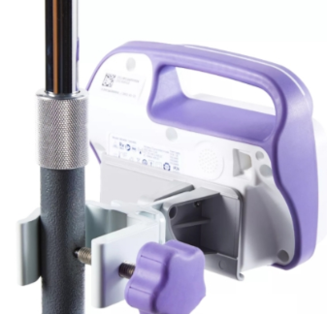
How do I attach the pole clamp for the pump?
- Place the inside of the clamp against the IV pole and turn the knob to the right to tighten the pole clamp against the IV pole.
- Rotate the plastic latch plate on the pole clamp so that the “slide and click” feature looks like an upside down letter “U” and the arrow is pointing down.
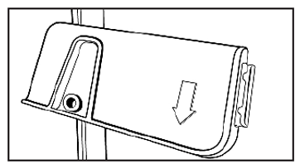
  - Note: You can rotate the plastic latch plate 90 degrees. To rotate it, hold and twist the latch plate until it “pops” into the next position.
- Place the back of the pump against the flat part of the latch plate. Line it up with the latch plate guide (the upside down “U”).
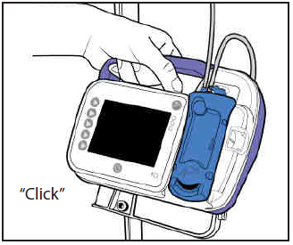
- Slide the pump down while keeping contact with the latch plate guide until you hear a click. This means that the pump is properly attached to the pole clamp.
- To remove the pump from the pole clamp, gently pull up.

How do I clean the pump?
- Clean the outside of the pump every day, using a mild dish soap and a damp cloth or sponge.
- Do not clean the pump or accessories while it is plugged into an electrical outlet, and do not plug the pump in until it is completely dry after cleaning.
- For hard-to-reach areas, you may wash the feeding pump under running water. Do not submerge the pump (put the pump completely underwater).
- Do not use any other cleaning products on the pump.

How can I keep the pump working safely?
- Do not drop or hit the pump. If you drop the pump, always check the pump to be sure it is still working correctly.
- Usually other electronics in the home will not affect the feeding pump from working properly, but it is possible. Some devices that might affect the pump include cell phones, cordless telephones, microwave ovens, or security systems. If you own an electronic device with this symbol: , you should keep it away from the pump.

How do I plan for using the pump while traveling?
- If you plan to travel for a long period of time, please make sure you are prepared with enough supplies to take with you.
- If you use a pump to give your feedings and you are traveling out of state, we will be able to provide you with a back-up pump to take with you.
- If you will be taking your feeding pump on an airplane, please call HomeMed for further instructions.

Troubleshooting issues with the Kangaroo OMNI™ pump
The pump will sound an alarm and show a message on the screen if there is a problem during use. Refer to the following information to fix errors or alarms. If you need more help, please call HomeMed at (800) 862-2731.

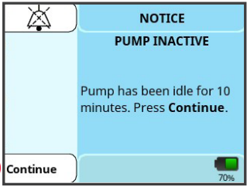 | PUMP INACTIVE  - The pump has been on hold for 10 minutes and is waiting for the next step. Press “Continue” to return to the previous screen.  - If this does not fix the problem, press the power button to turn the pump off and then turn the pump back on.
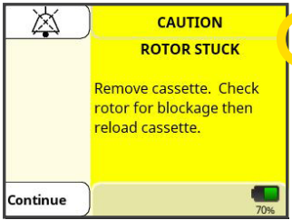 | ROTOR STUCK  - There is a problem with the rotor (the black wheel on the pump), such as the tubing being placed incorrectly or having formula build-up on the rotor from not cleaning the pump well enough.  - Remove the cassette from the pump and check the tubing for damage.  - Unplug the pump and clean the rotor.  - If there was no damage in the tubing, reload the cassette and press “Continue.”  - If this does not fix the problem, press the power button to turn the pump off and then back on.
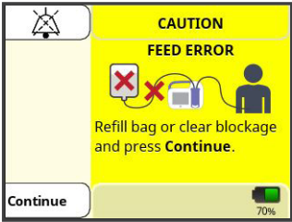 | FEED ERROR  - The feeding bag may be empty and need to be rinsed and refilled.  - There may be a clog or kink in the tubing between the bag and the pump. Fix the kink and press “Continue.”  - Disconnect the pump set from your feeding tube and use the prime function to clear any air bubbles.  - If this does not fix the problem, press the power button to turn off the pump and then back on.  - Unplug the pump and clean the area where the cassette gets loaded into the pump.  - You may need to try a new feeding bag.
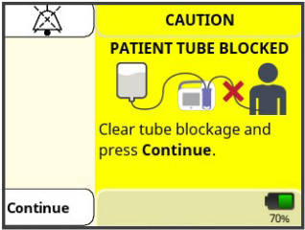 | PATIENT TUBE BLOCKED  - There may be a clog or kink in the tubing between the pump and the patient. Fix the kink and press “Continue.”  - Disconnect the pump set from your feeding tube and use the prime function to clear any air bubbles.  - If this does not fix the problem, press the power button to turn off the pump and then back on.  - Unplug the pump and clean the area where the cassette gets loaded into the pump.  - Make sure there is not a clog or a kink in your feeding tube.  - You may need to try a new feeding bag.
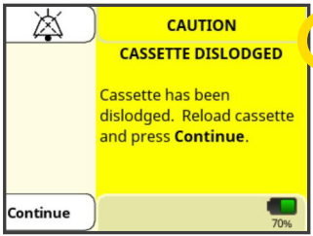  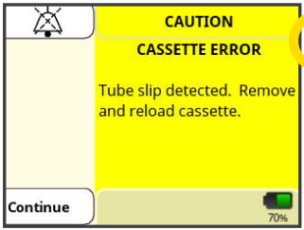  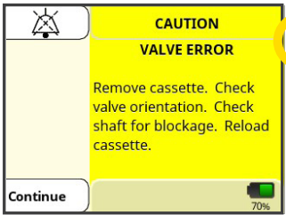  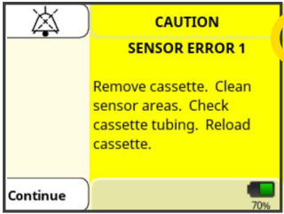 | CASSETTE DISLODGED, CASSETTE ERROR, VALVE ERROR, or SENSOR ERROR  - The cassette may not be loaded correctly into the pump, or it may be damaged or dirty. Remove the cassette, check it for dirt and damage, and reload it.  - If this does not fix the problem, press the power button to turn off the pump and then back on.  - Unplug the pump and clean the area where the cassette gets loaded into the pump.  - You may need to try a new feeding bag.
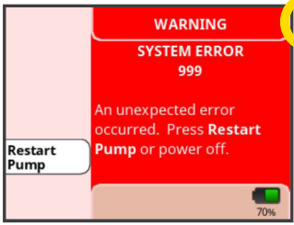 | SYSTEM ERROR  - The pump has an issue and must be restarted. Press “Restart Pump.” If this does not fix the problem, call HomeMed for help. You may need a new pump.
LOAD SET
- This is not an error screen, but you may experience a problem where the pump does not know that a feeding bag is loaded. Make sure you have loaded the cassette correctly.
- If the pump still does not show “SET LOADED,” then you have a defective (non-working) feeding bag. Try using a different bag and call HomeMed during regular business hours to replace the defective feeding bag.

What do I do if the pump will not work or if the power goes out?

Use one of the non-electric feeding methods:
- Feed with a syringe
- Feed with a gravity bag using hourly rate calculations

Read the next section for instructions for each feeding method.

Note: Children with tubes placed in the duodenum or jejunum will not be given a gravity bag for feedings. Please give them feedings using the syringe method.

Other feeding options

How do I give a feeding using a syringe?
- Wash your hands with soap and water.
- Flush the feeding tube with water before the feeding.
- Prepare your formula as instructed by your HomeMed provider.
- Using a syringe, pull up ¼ or 0.25 of the hourly pump rate of formula.
  - To find out how much formula to pull into the syringe, use this calculation: Hourly pump rate (mL/hr) multiplied by 0.25. So for example, if your hourly pump rate was 40 mL/hr, you would calculate 40 mL/hr x 0.25 = 10 mL, so you will give 10 mL of formula every 15 minutes.
- Slowly push the formula into the feeding tube.
- Repeat this process every 15 minutes.
- Flush the feeding tube with water after the formula has been given.

Other tips for syringe feeding:
- If you’re tolerating the feeding amounts well, you can try giving half of your hourly pump rate of formula every 30 minutes.
  - The new calculation for this would be: Hourly pump rate (mL/hr) multiplied by 0.5. So for example, if your hourly pump rate was 40 mL/hr, you would calculate 40 mL/hr x 0.5 = 20 mL, so you will give 20 mL of formula every 20 minutes.
- If you typically only use your feeding pump overnight, you can reschedule your night feeds to the next day so you don’t miss sleep!

How do I give a feeding using a gravity bag?

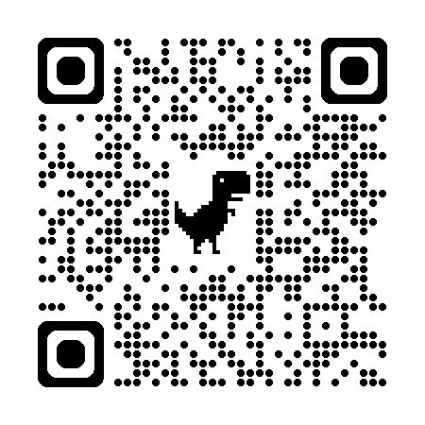
The Kangaroo OMNI™ feeding bag will not work for the gravity bag feeding method. Please use the gravity feeding bag that we sent you in your first supplies delivery. To use your gravity bag, follow the instructions below or scan the QR code to watch a gravity feeding training video.

- Gather your supplies:
- Gravity tube feeding bag
- Formula
- A cup of warm water
- A syringe for flushing
- Wash your hands with soap and water.
- Flush your feeding tube with the recommended amount of water.
- Prepare your formula as instructed by your provider.
- Be sure the roller clamp on the gravity feeding bag is closed (roll the wheel all the way down).
- Pour 1-2 cans of formula into the feeding bag.
- Hang the feeding bag on the IV pole. If you do not have an IV pole, use a hook or nail in the wall to keep the feeding bag in place. The gravity bag must be above the level of the chest and stomach to work.
- To prime the tubing, squeeze and release the drip chamber until the formula fills to the line marked in the chamber. Open the roller clamp to allow the formula to flow to the end of the tubing. Close the clamp.
- Insert the end of the feeding bag into your feeding tube, unroll the roller clamp, and allow the formula to flow until the feeding bag is empty.
- You can control how fast the formula is given by gravity by adjusting the roller clamp. Watch the drip chamber and time the drips based on the table below:

If your pump rate is: | Your drip rate should be:
60 mL/hr | 4 drips every 15 seconds
80 mL/hr | 5 drips every 15 seconds
100 mL/hr | 6 drips every 15 seconds
120 mL/hr | 7 drips every 15 seconds
140 mL/hr | 8 drips every 15 seconds

- Flush your feeding tube with the recommended amount of water.

Disclaimer: This document contains information and/or instructional materials developed by University of Michigan Health for the typical patient with your condition. It may include links to online content that was not created by U-M Health and for which U-M Health does not assume responsibility. It does not replace medical advice from your health care provider because your experience may differ from that of the typical patient. Talk to your health care provider if you have any questions about this document, your condition, or your treatment plan.

Author: Allison Jay, MS RDN
Reviewer: Kaitlin Crowell, RDN CNSC
Edited by: Brittany Batell, MPH MSW CHES®
Images used with permission from Cardinal Health. Cardinal Health has not endorsed or approved this training material.
Patient Education by University of Michigan Health is licensed under a Creative Commons Attribution-NonCommercial-ShareAlike 4.0 International Public License. Last revised 02/2025

